 | 13.1.10 Editors - Shader Editor - Header - Add Menu - Texture
Table of content
Detailed Table of content 1
Add menu - Texture 6
Brick Texture 6
Checker Texture 7
Environment Texture 8
Gabor Texture 9
Gradient Texture 10
IES Texture 11
Image Texture 12
Magic Texture 14
Noise Texture 15
Sky Texture 18
Voronoi Texture 19
Wave Texture 21
White Noise Texture 23

Detailed Table of content
Detailed table of content
Detailed Table of content 1
Add menu - Texture 6
Brick Texture 6
Inputs 6
Color 1, Color 2 and Mortar 6
Scale 6
Mortar Size 6
Mortar Smooth 6
Bias 6
Brick Width 6
Row Height 6
Properties 7
Offset 7
Frequency 7
Squash 7
Frequency 7
Outputs 7
Color 7
Factor 7
Checker Texture 7
Inputs 7
Vector 7
Color1, Color 2 7
Scale 7
Outputs 8
Color 8
Factor 8
Environment Texture 8
Inputs 8
Vector 8
Properties 8
Image 8
Color Space 8
Texture Interpolation 8
Linear 8
Closest 8
Cubic 8
Smart 8
Projection Method 9
Equirectangular 9
Mirror Ball 9
Outputs 9
Color 9
Gabor Texture 9
Inputs 9
Vector 9
Scale 9
Frequency 9
Anisotropic 9
Orientation 9
Properties 10
Type 10
Outputs 10
Value 10
Phase 10
Intensity 10
Gradient Texture 10
Inputs 10
Vector 10
Properties 10
Gradient Type 10
Linear 10
Quadratic 10
Easing 10
Diagonal 10
Spherical 11
Quadratic Sphere 11
Radial 11
Outputs 11
Color 11
Factor 11
IES Texture 11
Inputs 11
Vector 11
Strength 11
Properties 11
Mode 11
Internal 11
External 11
Outputs 11
Factor 11
Image Texture 12
Inputs 12
Vector 12
Properties 12
Image 12
Interpolation 12
Linear 12
Cubic 13
Closest 13
Smart 13
Projection 13
Flat 13
Box 13
Blend 13
Sphere 13
Tube 13
Extension 13
Repeat 13
Extend 13
Clip 14
Source 14
Color Space 14
Alpha 14
Outputs 14
Color 14
Alpha 14
Magic Texture 14
Inputs 14
Vector 14
Scale 15
Distortion 15
Properties 15
Depth 15
Outputs 15
Color 15
Factor 15
Noise Texture 15
Inputs 15
Vector 16
Normalize 16
W 16
Scale 16
Detail 16
Roughness 16
Lacunarity 16
Offset 16
Gain 16
Distortion 16
Properties 16
Dimensions 16
1D 16
2D 16
3D 16
4D 17
Type 17
Multifractal 17
Ridged Multifractal 17
Hybrid Multifractal 17
fBM (fractal Brownian Motion) 17
Hetero Terrain (Heterogeneous Terrain) 17
Outputs 17
Factor 17
Color 17
Sky Texture 18
Inputs 18
Vector 18
Properties 18
Sky Type 18
Sun disc 18
Sun Size 18
Sun Intensity 18
Sun Elevation 18
Sun Rotation 18
Sun Altitude 18
Air 18
Dust 18
Ozone 19
Outputs 19
Color 19
Voronoi Texture 19
Inputs 19
Vector 19
W 19
Scale 19
Detail 19
Roughness 19
Lacunarity 19
Randomness 19
Properties 20
Dimensions 20
1D 20
2D 20
3D 20
4D 20
Feature 20
F1 20
Smooth F1 20
Distance To Edge 20
N-Sphere Radius 20
Distance Metric 20
Euclidean 20
Manhattan 20
Chebychev 20
Minkowski 21
Outputs 21
Distance 21
Color 21
Position 21
W 21
Wave Texture 21
Inputs 21
Vector 21
Scale 21
Distortion 21
Detail 21
Detail Scale 22
Detail Roughness 22
Phase Offset 22
Properties 22
Wave Type 22
Bands direction 22
Wave Profile 22
Saw 22
Sine 22
Triangle 22
Outputs 22
Color 22
Factor 22
White Noise Texture 23
Inputs 23
Vector 23
W 23
Properties 23
Dimensions 23
1D 23
2D 23
3D 23
4D 23
Outputs 23
Value 23

Add menu - Texture
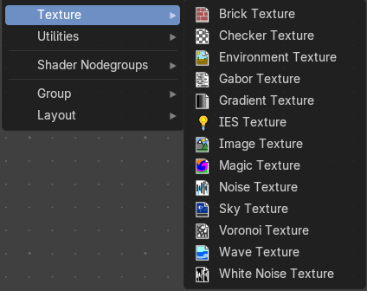
Here are the texture nodes. They allow you to add different texture types to the scene. The content is the same for the sub modes and the different renderers. However, a environment texture just makes sense for the world sub mode.

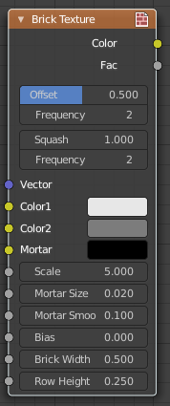
Brick Texture
The Brick Texture node is used to add a procedural brick texture.

Inputs

Color 1, Color 2 and Mortar
Color of the bricks and mortar.

Scale
Overall texture scale.

Mortar Size
The size of the filling between the bricks known as “mortar”; 0 means no mortar.

Mortar Smooth
Blurs/softens the edge between the mortar and the bricks. This can be useful with a texture and displacement textures.

Bias
The color variation between Color 1/2. Values of -1 and 1 only use one of the two colors; values in between mix the colors.

Brick Width
The width of the bricks.

Row Height
The height of the brick rows.

Properties

Offset
Determines the brick offset of the various rows.

Frequency
Determines the offset frequency. A value of 2 gives an even/uneven pattern of rows.

Squash
Amount of brick squashing.

Frequency
Brick squashing frequency.

Outputs

Color
Texture color output.

Factor
Mortar mask (1 = mortar).

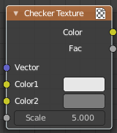
Checker Texture
The Checker Texture node adds a procedural checkerboard texture.

Inputs

Vector
Texture coordinate to sample texture at; defaults to Generated texture coordinates if the socket is left unconnected.

Color1, Color 2
Color of the checkers.

Scale
Overall texture scale. The scale is a factor of the bounding box of the face divided by the scale. For example, a scale of 15 will result in 15 alternate patterns over the overall UV bounding box. Different patterns could be achieved using other nodes to give different input patterns to this socket. For example, using the Math Node.

Outputs

Color
Texture color output.

Factor
Checker 1 mask (1 = Checker 1).

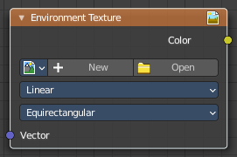
Environment Texture
Load an environment texture to light your scene.

Inputs

Vector
Texture coordinate for texture look-up. If this socket is left unconnected, the image is mapped as environment with the Z axis as up.

Properties

Image
Image data-block used as the image source. Additional settings can be found in Sidebar > Item > Properties: These include options to control the alpha channel along with addition options for the color space. These addition options are documented with the rest of Common Image Settings.

Color Space
Type of data that the image contains, either Color or Non-Color Data. For most color textures the default of Color should be used, but in case of e.g. a bump or alpha map, the pixel values should be interpreted as Non-Color Data, to avoid doing any unwanted color space conversions.

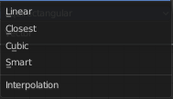
Texture Interpolation
Interpolation method used for the environment texture.

Linear
Regular quality interpolation.

Closest
No interpolation, use closest pixel.

Cubic
Smoother, better quality interpolation.

Smart
Bicubic when magnifying, otherwise Bilinear is used. This is only available for OSL.

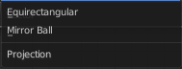
Projection Method
Allows you to use different types of environmental maps.

Equirectangular
Projection from an Equirectangular photo.

Mirror Ball
Projection from an orthographic photo or mirror ball.

Outputs

Color
RGB color from the image.

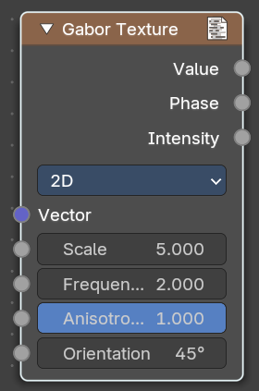
Gabor Texture
The Gabor Texture is a special directional noise texture from the OSL Shading language.

Inputs

Vector
Texture coordinate to sample texture at defaults to Generated texture coordinates if the socket is left unconnected.

Scale
The scale of the Gabor noise.

Frequency
The rate at which the Gabor noise changes across space. It differs from the input scale in that it only scales perpendicular to the gabor noise direction.

Anisotropic
The directionality of the Gabor noise. 1 means the noise is completely directional. With a value of 0 the noise goes in all directions.

Orientation
The direction of the anisotropic Gabor noise. With the 2ds method you have a orientation value. With the 3d method you will have a trackball to adjust the orientation.

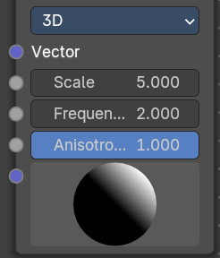
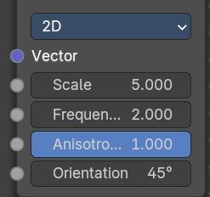
Properties

Type
2D ignores the Z input. 3D goes in all 3 directions.

Outputs

Value
The Gabor noise value with both, random phase and random intensity.

Phase
The phase of the Gabor noise, without random intensity.

Intensity
The intensity of the Gabor noise, withbout random phase.

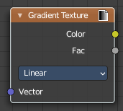
Gradient Texture
The Gradient Texture node generates interpolated color and intensity values based on the input vector.

Inputs

Vector
Texture coordinate to sample texture at; defaults to Generated texture coordinates if the socket is left unconnected.

Properties

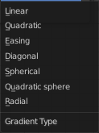
Gradient Type
Controls the type of gradient generated.

Linear
Directly returns the input X coordinate.

Quadratic
Interpolates the input X coordinate quadratically.

Easing
Uses a combination of quadratic and linear interpolation to return a smooth gradient from the input X coordinate.

Diagonal
Averages the input X and Y coordinates.

Spherical
Creates an inverse gradient using the length of the input vector; the maximum value is at (0, 0, 0).

Quadratic Sphere
The same as Spherical, except interpolated quadratically.

Radial
Returns a value based on the angle of the input around the Z axis.

Outputs

Color
Texture color output.

Factor
Texture intensity output.

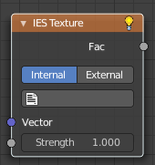
IES Texture
The IES Texture is used to match real world lights based on IES files. IES files store the directional intensity distribution of light sources.

Inputs

Vector
Texture coordinate for lookup in the light distribution. Defaults to the normal.

Strength
Light strength multiplier.

Properties

Mode

Internal
Use IES profile from a file embedded in a text data-block in the blend-file, for easy distribution.

External
Load IES profile from a file on the drive.

Outputs

Factor
Light intensity, typically plugged into the Strength input of an Emission node.

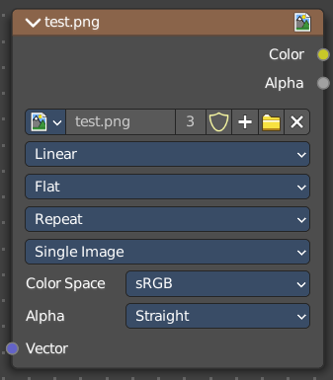
Image Texture
The Image Texture is used to add an image file as a texture.

Inputs

Vector
Texture coordinate for texture look-up. If this socket is left unconnected, UV coordinates from the active UV render layer are used.

Properties

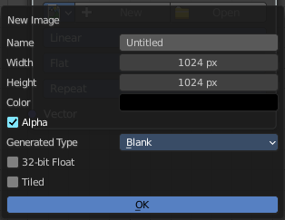
Image
Open an image, choose an existing image, or generate a new image.
When you click at Open then a file browser opens up. When you click at New then a popup dialog opens. up where you can create a new image.

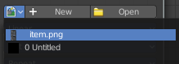
The image browser at the left allows you to pick an already existing texture from the scene.
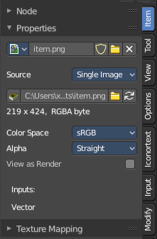
More image settings can be found in the Sidebar in the Items tab. Usually you find in the Item tab the very same settings like in the selected node. But the Image texture node is an exception. It shows here the usual image related settings too. This will be explained in the sidebar chapter.

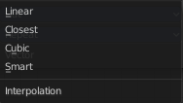
Interpolation
Method to scale images up or down for rendering.

Linear
Regular quality interpolation.

Cubic
Smoother, better quality interpolation. For bump maps this should be used to get best results.

Closest
No interpolation, use only closest pixel for rendering pixel art.

Smart
Cycles Only
Only for Open Shading Language. Use cubic interpolation when scaling up and linear when scaling down, for a better performance and sharpness.

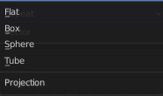
Projection
Projection to use for mapping the textures.

Flat
Uses the XY coordinates for mapping.

Box
Maps the image to the six sides of a virtual box, based on the normal, using XY, YZ and XYZ coordinates depending on the side.

Blend
For Box mapping, the amount to blend between sides of the box, to get rid of sharp transitions between the different sides. Blending is useful to map a procedural-like image texture pattern seamlessly on a model. 0.0 gives no blending; higher values give a smoother transition.

Sphere
Sphere mapping is the best type for mapping a sphere, and it is perfect for making planets and similar objects. It is often very useful for creating organic objects.

Tube
Maps the texture around an object like a label on a bottle. The texture is therefore more stretched on the cylinder. This mapping is of course very good for making the label on a bottle, or assigning stickers to rounded objects. However, this is not a cylindrical mapping so the ends of the cylinder are undefined.

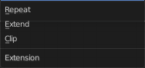
Extension
Extension defines how the image is extrapolated past the original bounds:

Repeat
Will repeat the image horizontally and vertically giving tiled-looking result.

Extend
Will extend the image by repeating pixels on its edges.

Clip
Clip to the original image size and set all the exterior pixels values to transparent black.

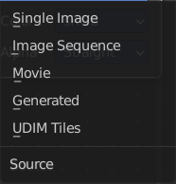
Source
What kind of image it is. The terms should be self explaining.

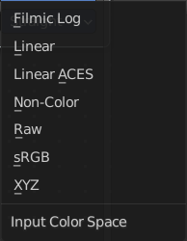
Color Space
What color space is used for the image.

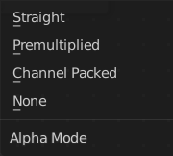
Alpha
What alpha mode is used for the image.

Outputs

Color
RGB color from image. If the image has alpha, the color is premultiplied with alpha if the Alpha output is used, and unpremultiplied or straight if the Alpha output is not used.

Alpha
Alpha channel from image.

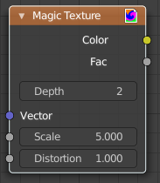
Magic Texture
The Magic Texture node is used to add a procedural psychedelic color texture.

Inputs

Vector
Texture coordinate to sample texture at; defaults to Generated texture coordinates if the socket is left unconnected.

Scale
Scale of the texture.

Distortion
Amount of distortion.

Properties

Depth
Number of iterations.

Outputs

Color
Texture color output.

Factor
Texture intensity output.

Noise Texture
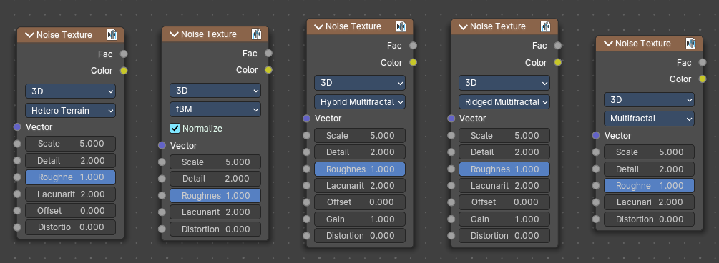
The Noise Texture node evaluates a fractal Perlin noise at the input texture coordinates. This nodes allows great control over how noise octaves are combined.

Inputs
The inputs are dynamic, they become available if needed depending on the node properties.

Vector
Texture coordinate to evaluate the noise at; defaults to Generated texture coordinates if the socket is left unconnected.

Normalize
Normalize the output to the 0 - 1 range.

W
Texture coordinate to evaluate the noise at. Appears with 4 dimensions.

Scale
Scale of the base noise octave.

Detail
Number of noise octaves. The fractional part of the input is multiplied by the magnitude of the highest octave. Higher number of octaves corresponds to a higher render time.

Roughness
Adds a roughness noise.

Lacunarity
The scale of a perlin noise octave relative to the perlin noise octave from the previous octave.

Offset
An added offset to each octave, determines the level where the highest octave will appear.

Gain
An extra multiplier to tune the magnitude of octaves.

Distortion
Amount of distortion.

Properties

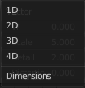
Dimensions
The dimensions of the space to evaluate the noise in.

1D
Evaluate the noise in 1D space at the input W.

2D
Evaluate the noise in 2D space at the input Vector. The Z component is ignored.

3D
Evaluate the noise in 3D space at the input Vector.

4D
Evaluate the noise in 4D space at the input Vector and the input W as the fourth dimension.

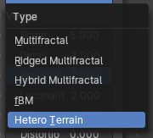
Type
Type of the perlin noise texture.

Multifractal
The result is more uneven (varies with location), more similar to a real terrain. Uses a multiplicative cascade.

Ridged Multifractal
Creates sharp peaks. Calculates the absolute value of the noise, creating “canyons”, and then flips the surface upside down.

Hybrid Multifractal
Creates peaks and valleys with different roughness values, like real mountains rise out of flat plains. Combines the additive cascade with a multiplicative cascade.

fBM (fractal Brownian Motion)
Produces an unnatural homogeneous and isotropic result. Uses an additive cascade, the values are simply added together.

Hetero Terrain (Heterogeneous Terrain)
Similar to Hybrid Multifractal creates a heterogeneous terrain, but with the likeness of river channels.

Outputs

Factor
Value of fractal noise.

Color
Color with different fractal noise in each component.

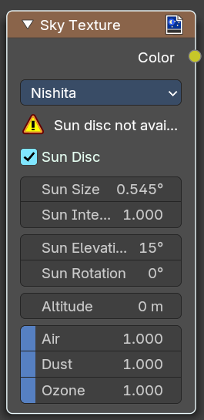
Sky Texture
The Sky Texture node adds a procedural Sky texture.

Inputs

Vector
Texture coordinate to sample texture at; defaults to Generated texture coordinates if the socket is left unconnected.

Properties


Sky Type
Sky model to use. There is currently just Nishita left as a choice.

Sun disc
Include the sun disc itself into the outpup.
Note that the sun disc is just available with the Cycles renderer. Not with the workbench or Eevee.

Sun Size
The sun size.

Sun Intensity
The sun intensity.

Sun Elevation
The sun elevation.

Sun Rotation
The sun rotation.

Sun Altitude
The sun altitude.

Air
Air influence.

Dust
Dust strength.

Ozone
Ozone influence.

Outputs

Color
Texture output.

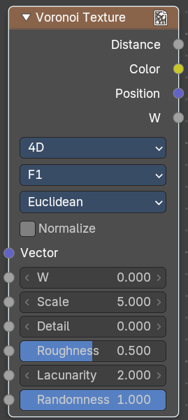
Voronoi Texture
The Voronoi Texture node evaluates a Worley Noise at the input texture coordinates.

Inputs
The inputs are dynamic, they become available if needed depending on the node properties.

Vector
Texture coordinate to evaluate the noise at; defaults to Generated texture coordinates if the socket is left unconnected.

W
The W Texture coordinate to evaluate the noise at (4D)

Scale
Scale of the noise.

Detail
The number of voronoi layers.

Roughness
The influence of a voronoi layer relative to the previous layer.

Lacunarity
The scale of a voronoi layer relative to the previous layer.

Randomness
The randomness of the noise.

Properties

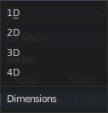
Dimensions
The dimensions of the space to evaluate the noise in.

1D
Evaluate the noise in 1D space at the input W.

2D
Evaluate the noise in 2D space at the input Vector. The Z component is ignored.

3D
Evaluate the noise in 3D space at the input Vector.

4D
Evaluate the noise in 4D space at the input Vector and the input W as the fourth dimension.

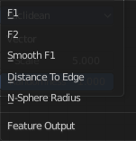
Feature
The Voronoi feature that the node will compute and return.

F1
Compute and return the distance to the closest feature point as well as its position and color.

Smooth F1
Compute and return a smooth version of F1.

Distance To Edge
Compute and return the distance to the edges of the Voronoi cells.

N-Sphere Radius
Compute and return the radius of the n-sphere inscribed in the Voronoi cells. In other words, it is half the distance between the closest feature point and the feature point closest to it.

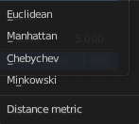
Distance Metric
The distance metric used to compute the texture.

Euclidean
Use the Euclidean distance metric.

Manhattan
Use the Manhattan distance metric.

Chebychev
Use the Chebychev distance metric.

Minkowski
Use the Minkowski distance metric. The Minkowski distance is a generalization of the aforementioned metrics with an Exponent as a parameter. Minkowski with an exponent of one is equivalent to the Manhattan distance metric. Minkowski with an exponent of two is equivalent to the Euclidean distance metric. Minkowski with an infinite exponent is equivalent to the Chebychev distance metric.

Outputs

Distance
The Distance.

Color
Cell color. The color is arbitrary.

Position
Position of feature point.

W
Position of feature point.
Note. In some configurations of the node, especially for low values of Randomness, rendering artifacts may occur. This happens due to the same reasons described in the Notes section in the White Noise Texture page and can be fixed in a similar manner as described there.

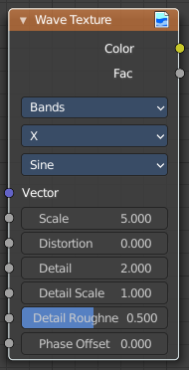
Wave Texture
The Wave Texture node adds procedural bands or rings with noise distortion.

Inputs

Vector
Texture coordinate to sample texture at; defaults to Generated texture coordinates if the socket is left unconnected.

Scale
Overall texture scale.

Distortion
Amount of distortion of the wave (similar to the Marble texture in Blender Internal).

Detail
Amount of distortion noise detail.

Detail Scale
Scale of distortion noise.

Detail Roughness
Adds a roughness noise.

Phase Offset
Set an offset for the phase.

Properties

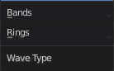
Wave Type
Bands or Rings shaped waves.

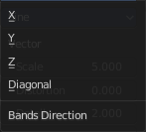
Bands direction
In which direction the bands should point.

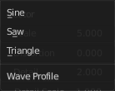
Wave Profile
Controls the shape and look of the wave type.

Saw
Uses a saw tooth profile.

Sine
Uses the standard sine profile.

Triangle
Uses a triangle shape.

Outputs

Color
Texture color output.

Factor
Texture intensity output.

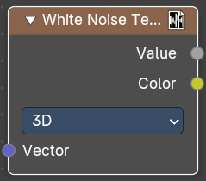
White Noise Texture
This node adds noise.

Inputs
The inputs are dynamic, they become available if needed depending on the node properties.

Vector
Vector used as seed in 2D, 3D, and 4D dimensions.

W
Value used as seed in 1D and 4D dimensions.

Properties

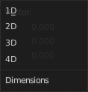
Dimensions
The dimensions of the space to evaluate the noise in.

1D
The W input is used as seed.

2D
The X and Y components of the Vector input are used as seed.

3D
The Vector input is used as seed.

4D
Both the Vector input and the W input are used as seed.

Outputs

Value
Output random value.
Note! The slightest difference in seed values would result in completely different outputs. Consequently, bad precision may have significant impact on the output. Usually, we can mitigate this issue by:
Eliminating the problematic seed value. If the problematic seed value is constant, it should be eliminated by choosing a lower dimension or multiplying it by zero.
Adding an arbitrary value to the seed. The issue might only happen at certain boundaries, like unit boundaries, so simply adding an arbitrary value might solve the issue.
Taking the absolute value of the seed. In computing, zero may be positive or negative, so taking the absolute values unifies the zero into a single value.

